Database Management System
Database Management System is a software or technology used to manage data from a database. Some popular databases are MySQL, Oracle, MongoDB, etc. DBMS provides many operations e.g. creating a database, Storing in the database, updating an existing database, delete from the database. DBMS is a system that enables you to store, modify and retrieve data in an organized way. It also provides security to the database.
In this Database Management System tutorial you’ll learn basic to advanced topics like ER model, Relational Model, Relation Algebra, Normalization, File Organization, etc.

Advantages of DBMS
There are some following reasons to learn DBMS:
- Organizing and management of data: DBMS helps in managing large amounts of data in an organized manner. It provides features like create, edit, delete, and read.

- Data Security: DBMS provides Security to the data from the unauthorized person.

- Improved decision-making: From stored data in the database we can generate graphs, reports, and many visualizations which helps in decision-making.

- Consistency: In a traditional database model all things are manual or inconsistent, but DBMS enables to automation of the operations by queries.

Q.1 What is Database?
Answer:
A database is a collection of organized data which can easily be created, updated, accessed, and managed. Records are kept maintained in tables or objects. A tuple (row) represents a single entry in a table. DBMS manipulates data from the database in the form of queries given by the user.

Q.2 What are different languages present in DBMS?
Answer:
- DDL (Data Definition Language): These are the collection of commands which are required to define the database.
E.g., CREATE, ALTER, RENAME, TRUNCATE, DROP, etc.
- DML (Data Manipulation Language): These are the collection of commands which are required to manipulate the data stored in a database.
E.g., SELECT, UPDATE, INSERT, DELETE, etc.
- DCL (Data Control Language): These are the collection of commands which are dealt with the user permissions and controls of the database system.
E.g, GRANT, and REVOKE.
- TCL (Transaction Control Language): These are the collection of commands which are required to deal with the transaction of the database.
E.g., COMMIT, ROLLBACK, and SAVEPOINT.

Q.3 What are the ACID properties in DBMS?
Answer:
The full form of ACID is Atomicity, Consistency, Isolation, and Durability these are the properties of DBMS that ensure a safe and secure way of sharing data among multiple users.
A – Atomic: All changes to the data must be performed successfully or not at all.
C – Consistent: Data must be in a consistent state before and after the transaction.
I – Isolated: No other process can change the data while the transaction is going on.
D – Durable: The changes made by a transaction must persist.

Q.4 What are the Advantages of DBMS?
Answer:
The followings are the few advantages of DBMS :
- Data Sharing: Data from the same database can be shared by multiple users at the same time.
- Integrity: It allows the data stored in an organized and refined manner.
- Data Independence: It allows changing the data structure without changing the composition of executing programs.
- Data Security: DBMS comes with the tools to make the storage and transfer of databases secure and reliable. Authentication and encryption are the tools used in DBMS for data security.
INTRODUCTION:
A Database Management System (DBMS) is a software system that is designed to manage and organize data in a structured manner. It allows users to create, modify, and query a database, as well as manage the security and access controls for that database.
Some key features of a DBMS include:
- Data modeling: A DBMS provides tools for creating and modifying data models, which define the structure and relationships of the data in a database.
- Data storage and retrieval: A DBMS is responsible for storing and retrieving data from the database, and can provide various methods for searching and querying the data.
- Concurrency control: A DBMS provides mechanisms for controlling concurrent access to the database, to ensure that multiple users can access the data without conflicting with each other.
- Data integrity and security: A DBMS provides tools for enforcing data integrity and security constraints, such as constraints on the values of data and access controls that restrict who can access the data.
- Backup and recovery: A DBMS provides mechanisms for backing up and recovering the data in the event of a system failure.
- DBMS can be classified into two types: Relational Database Management System (RDBMS) and Non-Relational Database Management System (NoSQL or Non-SQL)
- RDBMS: Data is organized in the form of tables and each table has a set of rows and columns. The data is related to each other through primary and foreign keys.
- NoSQL: Data is organized in the form of key-value pairs, document, graph, or column-based. These are designed to handle large-scale, high-performance scenarios.
Database is a collection of interrelated data which helps in the efficient retrieval, insertion, and deletion of data from the database and organizes the data in the form of tables, views, schemas, reports, etc. For Example, a university database organizes the data about students, faculty, admin staff, etc. which helps in the efficient retrieval, insertion, and deletion of data from it.
There are four types of Data Languages
- Data Definition Language (DDL)
- Data Manipulation Language(DML)
- Data Control Language(DCL)
- Transactional Control Language(TCL)

DDL is the short name for Data Definition Language, which deals with database schemas and descriptions, of how the data should reside in the database.
- CREATE: to create a database and its objects like (table, index, views, store procedure, function, and triggers)
- ALTER: alters the structure of the existing database
- DROP: delete objects from the database
- TRUNCATE: remove all records from a table, including all spaces allocated for the records are removed
- COMMENT: add comments to the data dictionary
- RENAME: rename an object

DML is the short name for Data Manipulation Language which deals with data manipulation and includes most common SQL statements such SELECT, INSERT, UPDATE, DELETE, etc., and it is used to store, modify, retrieve, delete and update data in a database.
- SELECT: retrieve data from a database
- INSERT: insert data into a table
- UPDATE: updates existing data within a table
- DELETE: Delete all records from a database table
- MERGE: UPSERT operation (insert or update)
- CALL: call a PL/SQL or Java subprogram
- EXPLAIN PLAN: interpretation of the data access path
- LOCK TABLE: concurrency Control

DCL is short for Data Control Language which acts as an access specifier to the database.(basically to grant and revoke permissions to users in the database
- GRANT: grant permissions to the user for running DML(SELECT, INSERT, DELETE,…) commands on the table
- REVOKE: revoke permissions to the user for running DML(SELECT, INSERT, DELETE,…) command on the specified table

TCL is short for Transactional Control Language which acts as an manager for all types of transactional data and all transactions.Some of the command of TCL are
- Roll Back: Used to cancel or Undo changes made in the database
- Commit: It is used to apply or save changes in the database
- Save Point: It is used to save the data on the temporary basis in the database

Database Management System: The software which is used to manage databases is called Database Management System (DBMS). For Example, MySQL, Oracle, etc. are popular commercial DBMS used in different applications. DBMS allows users the following tasks:
- Data Definition: It helps in the creation, modification, and removal of definitions that define the organization of data in the database.
- Data Updation: It helps in the insertion, modification, and deletion of the actual data in the database.
- Data Retrieval: It helps in the retrieval of data from the database which can be used by applications for various purposes.
- User Administration: It helps in registering and monitoring users, enforcing data security, monitoring performance, maintaining data integrity, dealing with concurrency control, and recovering information corrupted by unexpected failure.

Paradigm Shift from File System to DBMS
File System manages data using files on a hard disk. Users are allowed to create, delete, and update the files according to their requirements. Let us consider the example of file-based University Management System. Data of students is available to their respective Departments, Academics Section, Result Section, Accounts Section, Hostel Office, etc. Some of the data is common for all sections like Roll No, Name, Father Name, Address, and Phone number of students but some data is available to a particular section only like Hostel allotment number which is a part of the hostel office. Let us discuss the issues with this system:
- Redundancy of data: Data is said to be redundant if the same data is copied at many places. If a student wants to change their Phone number, he or she has to get it updated in various sections. Similarly, old records must be deleted from all sections representing that student.
- Inconsistency of Data: Data is said to be inconsistent if multiple copies of the same data do not match each other. If the Phone number is different in Accounts Section and Academics Section, it will be inconsistent. Inconsistency may be because of typing errors or not updating all copies of the same data.
- Difficult Data Access: A user should know the exact location of the file to access data, so the process is very cumbersome and tedious. If the user wants to search the student hostel allotment number of a student from 10000 unsorted students’ records, how difficult it can be.
- Unauthorized Access: File Systems may lead to unauthorized access to data. If a student gets access to a file having his marks, he can change it in an unauthorized way.
- No Concurrent Access: The access of the same data by multiple users at the same time is known as concurrency. The file system does not allow concurrency as data can be accessed by only one user at a time.
- No Backup and Recovery: The file system does not incorporate any backup and recovery of data if a file is lost or corrupted.

ADVANTAGES OR DISADVANTAGES:

Advantages of using a DBMS:
- Data organization: A DBMS allows for the organization and storage of data in a structured manner, making it easy to retrieve and query the data as needed.
- Data integrity: A DBMS provides mechanisms for enforcing data integrity constraints, such as constraints on the values of data and access controls that restrict who can access the data.
- Concurrent access: A DBMS provides mechanisms for controlling concurrent access to the database, to ensure that multiple users can access the data without conflicting with each other.
- Data security: A DBMS provides tools for managing the security of the data, such as controlling access to the data and encrypting sensitive data.
- Backup and recovery: A DBMS provides mechanisms for backing up and recovering the data in the event of a system failure.
- Data sharing: A DBMS allows multiple users to access and share the same data, which can be useful in a collaborative work environment.

Disadvantages of using a DBMS:
- Complexity: DBMS can be complex to set up and maintain, requiring specialized knowledge and skills.
- Performance overhead: The use of a DBMS can add overhead to the performance of an application, especially in cases where high levels of concurrency are required.
- Scalability: The use of a DBMS can limit the scalability of an application, since it requires the use of locking and other synchronization mechanisms to ensure data consistency.
- Cost: The cost of purchasing, maintaining and upgrading a DBMS can be high, especially for large or complex systems.
- Limited use cases: Not all use cases are suitable for a DBMS, some solutions don’t need high reliability, consistency or security and may be better served by other types of data storage.
These are the main reasons which made a shift from file system to DBMS. Also, see
A Database Management System (DBMS) is a software system that allows users to create, maintain, and manage databases. It is a collection of programs that enables users to access and manipulate data in a database. A DBMS is used to store, retrieve, and manipulate data in a way that provides security, privacy, and reliability.

Some of the key features of a DBMS include:
- Data Definition: A DBMS allows users to define the structure of the database, including the tables, fields, and relationships between tables.
- Data Manipulation: A DBMS allows users to insert, update, and delete data in the database, as well as retrieve data using queries.
- Data Security: A DBMS provides security features to prevent unauthorized access to the database and to protect the data from theft, loss, or corruption.
- Data Integrity: A DBMS provides mechanisms to maintain the accuracy and consistency of the data in the database, including enforcing constraints, such as unique keys, foreign keys, and check constraints.
- Data Backup and Recovery: A DBMS provides mechanisms to back up the data in the database and to recover data in case of data loss or corruption.

There are several types of DBMS, including:
- Relational DBMS (RDBMS): An RDBMS stores data in tables with rows and columns, and uses SQL (Structured Query Language) to manipulate the data.
- Object-Oriented DBMS (OODBMS): An OODBMS stores data as objects, which can be manipulated using object-oriented programming languages.
- NoSQL DBMS: A NoSQL DBMS stores data in non-relational data structures, such as key-value pairs, document-based models, or graph models.

DBMS has many advantages, including:
- Improved data sharing: A DBMS allows multiple users to access and manipulate data in the database simultaneously.
- Reduced data redundancy: A DBMS eliminates data redundancy by storing data in a centralized database.
- Improved data consistency: A DBMS enforces constraints to ensure data consistency and accuracy.
- Improved data security: A DBMS provides security features to protect the data from unauthorized access and to prevent data loss or corruption.
- Improved data integrity: A DBMS enforces data integrity constraints to ensure that the data in the database is accurate and consistent.
Overall, a DBMS is a powerful tool for managing and manipulating data, and is used in many industries and applications, such as finance, healthcare, retail, and more.

Difference between File System and DBMS

The file system is basically a way of arranging the files in a storage medium like a hard disk. The file system organizes the files and helps in the retrieval of files when they are required. File systems consist of different files which are grouped into directories. The directories further contain other folders and files. The file system performs basic operations like management, file naming, giving access rules, etc.

Example: NTFS(New Technology File System), EXT(Extended File System).
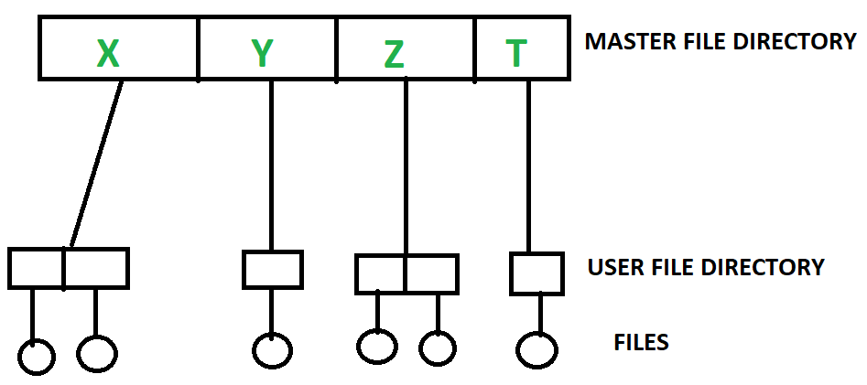
File System

DBMS(Database Management System)
Database Management System is basically software that manages the collection of related data. It is used for storing data and retrieving the data effectively when it is needed. It also provides proper security measures for protecting the data from unauthorized access. In Database Management System the data can be fetched by SQL queries and relational algebra. It also provides mechanisms for data recovery and data backup.

Example:
Oracle, MySQL, MS SQL server.
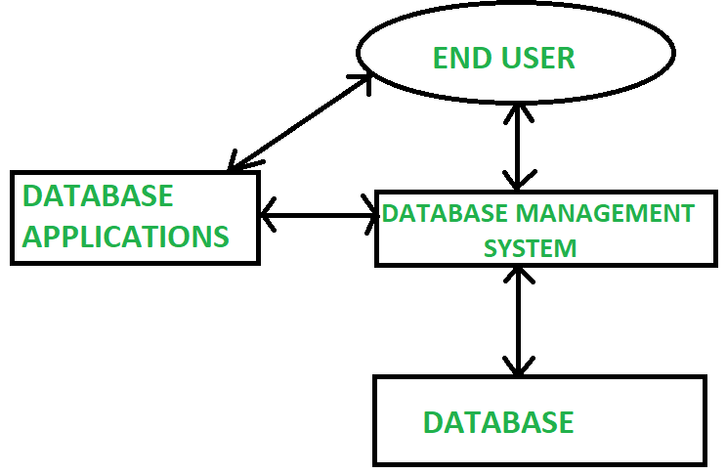

Difference between File System and DBMS
Basics | File System | DBMS
Structure | The file system is a way of arranging the files in a storage medium within a computer. | DBMS is software for managing the database.
Data Redundancy | Redundant data can be present in a file system. | In DBMS there is no redundant data.
Backup and Recovery | It doesn’t provide Inbuilt mechanism for backup and recovery of data if it is lost. | It provides in house tools for backup and recovery of data even if it is lost.
Query processing | There is no efficient query processing in the file system. | Efficient query processing is there in DBMS.
Consistency | There is less data consistency in the file system. | There is more data consistency because of the process of normalization.
Complexity | It is less complex as compared to DBMS. | It has more complexity in handling as compared to the file system.
Security Constraints | File systems provide less security in comparison to DBMS. | DBMS has more security mechanisms as compared to file systems.
Cost | It is less expensive than DBMS. | It has a comparatively higher cost than a file system.
Data Independence | There is no data independence. | In DBMS data independence exists, mainly of two types:  1) Logical Data Independence.  2)Physical Data Independence.
User Access | Only one user can access data at a time. | Multiple users can access data at a time.
Meaning | The users are not required to write procedures. | The user has to write procedures for managing databases
Sharing | Data is distributed in many files. So, it is not easy to share data. | Due to centralized nature data sharing is easy
Data Abstraction | It give details of storage and representation of data | It hides the internal details of Database
Integrity Constraints | Integrity Constraints are difficult to implement | Integrity constraints are easy to implement
Attributes | To access data in a file , user requires attributes such as file name, file location. | No such attributes are required.
Example | Cobol, C++ | Oracle, SQL Server

The main difference between a file system and a DBMS (Database Management System) is the way they organize and manage data.
- File systems are used to manage files and directories, and provide basic operations for creating, deleting, renaming, and accessing files. They typically store data in a hierarchical structure, where files are organized in directories and subdirectories. File systems are simple and efficient, but they lack the ability to manage complex data relationships and ensure data consistency.
- On the other hand, DBMS is a software system designed to manage large amounts of structured data, and provide advanced operations for storing, retrieving, and manipulating data. DBMS provides a centralized and organized way of storing data, which can be accessed and modified by multiple users or applications. DBMS offers advanced features like data validation, indexing, transactions, concurrency control, and backup and recovery mechanisms. DBMS ensures data consistency, accuracy, and integrity by enforcing data constraints, such as primary keys, foreign keys, and data types.
In summary, file systems are suitable for managing small amounts of unstructured data, while DBMS is designed for managing large amounts of structured data, and offers more advanced features for ensuring data integrity, security, and performance.

Difference between DELETE and TRUNCATE

DELETE vs TRUNCATE
Topic | DELETE | TRUNCATE
Definition | DELETE is a SQL command that removes one or multiple rows from a table using conditions. | TRUNCATE is a SQL command that removes all the rows from a table without using any condition.
Language | It is a DML(Data Manipulation Language) command. | It is a DDL(Data Definition Language) command.
Commit | We have to manually COMMIT the changes in the DELETE command. | The changes are automatically COMMIT in the TRUNCATE command.
Process | It deletes rows one by one with conditions. | It deletes all the data at once.
Condition | It uses the WHERE clause as a condition. | It does not take any condition i.e. does not use WHERE clause.
Lock | It locks all the rows for deletion. | It uses table lock to lock the pages for deletion.
Log | It logs every single record in the transaction log. | It only logs the deallocation of the pages where the data is stored.
Transaction space | It uses more transaction space compared to the TRUNCATION command. | It uses less transaction space compared to the DELETE command.
Identity | It does not reset the table identity to its seed value if there is an identity column. | It resets the table identity to its seed value.
Permission | It needs delete permission. | It needs alter table permission.
Speed | It is much slower when comes to big databases. | It is faster or in other words, instant.

DELETE or TRUNCATE: which is better?
Well, both the commands have different operations though their main task is to delete records from a table. Both the commands do not remove table schema, indices, constraints, triggers like the DROP command.
- If you want to delete all records of a table: Use TRUNCATE.
- If you want to delete specific records of a table: Use DELETE.

Frequently Asked Questions

1. TRUNCATE vs DELETE - which one should I choose?

2. Which is better, TRUNCATE or DELETE?

3. Why is TRUNCATE faster than DELETE?

4. What are the top differences between TRUNCATE and DELETE?
https://unstop.com/blog/difference-between-delete-and-truncate-in-sql

DBA Full Form – Database Administrator
Last Updated : 08 Jan, 2025

A Database Administrator (DBA) is an individual or person responsible for controlling, maintaining, coordinating, and operating a database management system. Managing, securing, and taking care of the database systems is a prime responsibility. They are responsible and in charge of authorizing access to the database, coordinating, capacity, planning, installation, and monitoring uses, and acquiring and gathering software and hardware resources as and when needed. Their role also varies from configuration, database design, migration, security, troubleshooting, backup, and data recovery. Database administration is a major and key function in any firm or organization that is relying on one or more databases. They are overall commanders of the Database system.

Types of Database Administrator (DBA)
- Administrative DBA: Their job is to maintain the server and keep it functional. They are concerned with data backups, security, troubleshooting, replication, migration, etc.
- Data Warehouse DBA: Assigned earlier roles, but held accountable for merging data from various sources into the data warehouse. They also design the warehouse, with cleaning and scrubs data prior to loading.
- Cloud DBA: Nowadays companies prefer to save their workpiece on cloud storage. As it reduces the chance of data loss and provides an extra layer of data security and integrity.
- Development DBA: They build and develop queries, store procedures, etc. that meet firm or organization needs.
- Application DBA: They particularly manage all requirements of application components that interact with the database and accomplish activities such as application installation and coordination, application upgrades, database cloning, data load process management, etc.
- Architect: They are held responsible for designing schemas like building tables. They work to build a structure that meets organizational needs. The design is further used by developers and development DBAs to design and implement real applications.
- OLAP DBA: They design and build multi-dimensional cubes for determination support or OLAP systems.
- Data Modeler –In general, a data modeler is in charge of a portion of a data architect’s duties. A data modeler is typically not regarded as a DBA, but this is not a hard and fast rule.
- Task-Oriented DBA: To concentrate on a specific DBA task, large businesses may hire highly specialised DBAs. They are quite uncommon outside of big corporations. Recovery and backup DBA, whose responsibility it is to guarantee that the databases of businesses can be recovered, is an example of a task-oriented DBA. However, this specialism is not present in the majority of firms. These task-oriented DBAs will make sure that highly qualified professionals are working on crucial DBA tasks when it is possible.
- Database Analyst: This position doesn’t actually have a set definition. Junior DBAs may occasionally be referred to as database analysts. A database analyst occasionally performs functions that are comparable to those of a database architect. The term “Data Administrator” is also used to describe database analysts and data analysts. Additionally, some businesses occasionally refer to database administrators as data analysts.

Importance of Database Administrator (DBA)
- Database Administrator manages and controls three levels of database internal level, conceptual level, and external level of Database management system architecture and in discussion with the comprehensive user community, gives a definition of the world view of the database. It then provides an external view of different users and applications.
- Database Administrator ensures held responsible to maintain integrity and security of database restricting from unauthorized users. It grants permission to users of the database and contains a profile of each and every user in the database.
- Database Administrators are also held accountable that the database is protected and secured and that any chance of data loss keeps at a minimum.
- Database Administrator is solely responsible for reducing the risk of data loss as it backup the data at regular intervals.

Role and Duties of Database Administrator (DBA)
- Decides Hardware: They decide on economical hardware, based on cost, performance, and efficiency of hardware, and best suits the organization. It is hardware that is an interface between end users and the database.
- Manages Data Integrity and Security: Data integrity needs to be checked and managed accurately as it protects and restricts data from unauthorized use. DBA eyes on relationships within data to maintain data integrity.
- Database Accessibility: Database Administrator is solely responsible for giving permission to access data available in the database. It also makes sure who has the right to change the content.
- Database Design: DBA is held responsible and accountable for logical, physical design, external model design, and integrity and security control.
- Database Implementation: DBA implements DBMS and checks database loading at the time of its implementation.
- Query Processing Performance: DBA enhances query processing by improving speed, performance, and accuracy.
- Tuning Database Performance: If the user is not able to get data speedily and accurately then it may lose organization’s business. So by tuning SQL commands DBA can enhance the performance of the database.

Various Responsibilities of Database Administrator (DBA)
- Responsible for designing overall database schema (tables & fields).
- To select and install database software and hardware.
- Responsible for deciding on access methods and data storage.
- DBA selects appropriate DBMS software like oracle, SQL server or MySQL.
- Used in designing recovery procedures.
- DBA decides the user access level and security checks for accessing, modifying or manipulating data.
- DBA is responsible for specifying various techniques for monitoring the database performance.
- DBA is responsible for operation managements.
- The operation management deals with the data problems which arises on day to day basis, and the responsibilities include are:
- Investigating if any error is been found in the data.
- Supervising of restart and recovery procedures in case of any event failure.
- Supervising reorganization of the databases.
- Controlling and handling all periodic dumps of data.

Skills Required for DBA
1. The various programming and soft skills are required to DBA are as follows,
- Good communication skills
- Excellent knowledge of databases architecture and design and RDBMS.
- Knowledge of Structured Query Language (SQL).
2. In addition, this aspect of database administration includes maintenance of data security, which involves maintaining security authorization tables, conducting periodic security audits, investigating all known security breaches.
3. To carry out all these functions, it is crucial that the DBA has all the accurate information about the company’s data readily on hand. For this purpose he maintains a data dictionary.
4. The data dictionary contains definitions of all data items and structures, the various schemes, the relevant authorization and validation checks and the different mapping definitions.
5. It should also have information about the source and destination of a data item and the flow of a data item as it is used by a system. This type of information is a great help to the DBA in maintaining centralized control of data.

Conclusion
A Database Administrator (DBA) is an individual or person responsible for controlling, maintaining, coordinating, and operating a database management system. Their role also varies from configuration, database design, migration, security, troubleshooting, backup, and data recovery. Database Administrator is responsible for reducing the risk of data loss as it backup the data at regular intervals.
DBA have information about the source and destination of a data item and the flow of a data item as it is used by a system. This type of information is a great help to the DBA in maintaining centralized control of data. They are overall commanders of the Database system.

